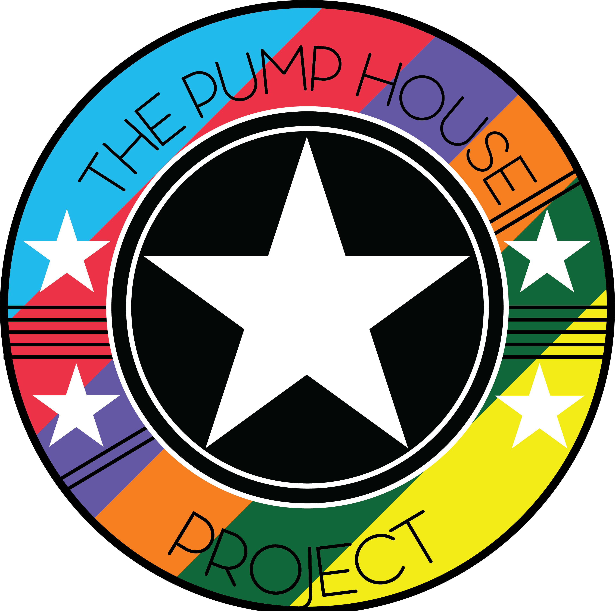

**Drug and Alcohol Policy**

The Pump House Project is committed to the personal and social development of people within its care.

We accept that some people may have drug or alcohol use issues or may come from families where there are drug and alcohol problems. These people may benefit from engaging in the activities that The Pump House Project provides.

However, drug or alcohol use or dealing will not be tolerated on The Pump House Project premises or during any activity organised or run by The Pump House Project.

The Pump House Project has a legal responsibility to ensure the health and safety of all its members and has a legal responsibility to adhere to laws pertaining to drugs and alcohol.

# Purpose of this policy

* This policy has been produced to give The Pump House Project staff and volunteers the necessary guidance to be able to deal with drug or alcohol related issues, which may arise as part of our work with the local community.
* This policy relates to illegal drugs (including cannabis) and alcohol. It excludes nicotine.
* This policy applies to The Pump House Project premises as well as activities and trips organised by The Pump House Project offsite.

# Responsibilities of staff and volunteers

* + All staff and volunteers will receive a copy of this policy as part of their induction.
  + Prior to and whilst on duty and responsible for service users, staff and volunteers are not permitted to consume drugs or alcohol. This includes any activities, residential or social activities where alcohol might be available.
  + When presenting themselves for work, all staff and volunteers must be in a fit and responsible state and on no account be under the influence of drugs/alcohol.
  + The Pump House Project expects all staff to adhere to a policy of total abstinence from drugs/alcohol prior to or whilst driving any vehicles during the course of their work.
  + Any drug or alcohol related incidents which occur should be reported to the Project Manager/Designated Safeguarding Officer at The Pump House Project and should be recorded.
  + If a young person is involved in a drug/alcohol related incident at The Pump House Project and the young person is under 18, a decision should be made whether the parents/guardians of the young person should be informed and involved.
  + Young people must not be under the influence of drugs or alcohol whilst taking part in any activity run by The Pump House Project.
  + The Project Manager should ensure that there are notices displayed in appropriate places around the building stating that drugs and alcohol are not allowed on the premises.
  + The notices should also state that anyone suspected of being under the influence of drugs/alcohol will not be allowed on the premises and there should also be an explanation of what will happen if the above is breached.
  + In 2001, the Government passed an amendment to Section 8 of the Misuse of Drugs Act. The new amendment which made it a criminal offence for people to knowingly allow premises they own, manage, or have responsibility for, to be used by any other person for:
    - Administration or use of any controlled drugs
    - Supply of any controlled drug
    - The production or cultivation of controlled drugs, such as growing cannabis Professionals could be prosecuted if they knowingly allow any of these things to

occur on The Pump House Project premises.

* The law requires that if staff become aware of the use or supply of illicit drugs on their premises, they must take reasonable action to prevent this continuing.
* If a person attends The Pump House Project and a member of staff has concerns about their drug/alcohol use, they should discuss these concerns with The Pump House Project and a decision made about the participation of the person.

# Storage of prescribed medication

* Before taking possession of any medication belonging to a person, staff should conduct a thorough risk assessment of the situation.
* Providing the risk assessment is satisfactory and depending on the medication and the issues surrounding the use of the medication, staff may take possession of prescribed drugs/medication on behalf of a young person in their care but they must not administer the medication.
* Any medication held by staff on behalf of a person must be kept in a secure place at all times and only named staff members should have access. The Project Manager should ensure that there is a suitable secure storage place at the establishment.
* If staff suspect that a person may have exceeded the stated dose of medication, they should contact emergency services immediately.

# Disposal of illegal substances

* If a member of staff or volunteer discovers a substance that they suspect to be drugs, they should inform the Project Manager and pass the drugs to the police for disposal.
* The incident should be recorded on the incident report form. If in doubt, contact the police and ask for their guidance on how to dispose of the substance; they may want to come and take it away.
* Staff must not attempt to pick up any needles, syringes or paraphernalia which they suspect may have been used to administer drugs, unless they have had the appropriate training.
* Needles and syringes should be placed in sharps box and the local council should be contacted to collect and dispose of the equipment. Involving the Police.
* Staff should work in partnership with the police by handing in any drugs found or confiscated during The Pump House Project activities.
* Where a situation arises that cannot be resolved by staff safely, an emergency call should be made to the police for assistance.
* If the police are called to deal with an incident involving a young person under the age of 18, the parents/guardians of the young person should be informed.

# Information, support and guidance

* + General drug and alcohol information should be available from Faringdon Town Council Youth Project including information about helpline numbers, websites and any local drug/alcohol support agencies.
  + All staff and volunteers will have the opportunity to undertake basic drug and alcohol training. This will be discussed and arranged with their line manager during supervision.

Policy written by: Sarah Stoves – Project Manager Date: 05/09/2019 Updated: 13/05/2024