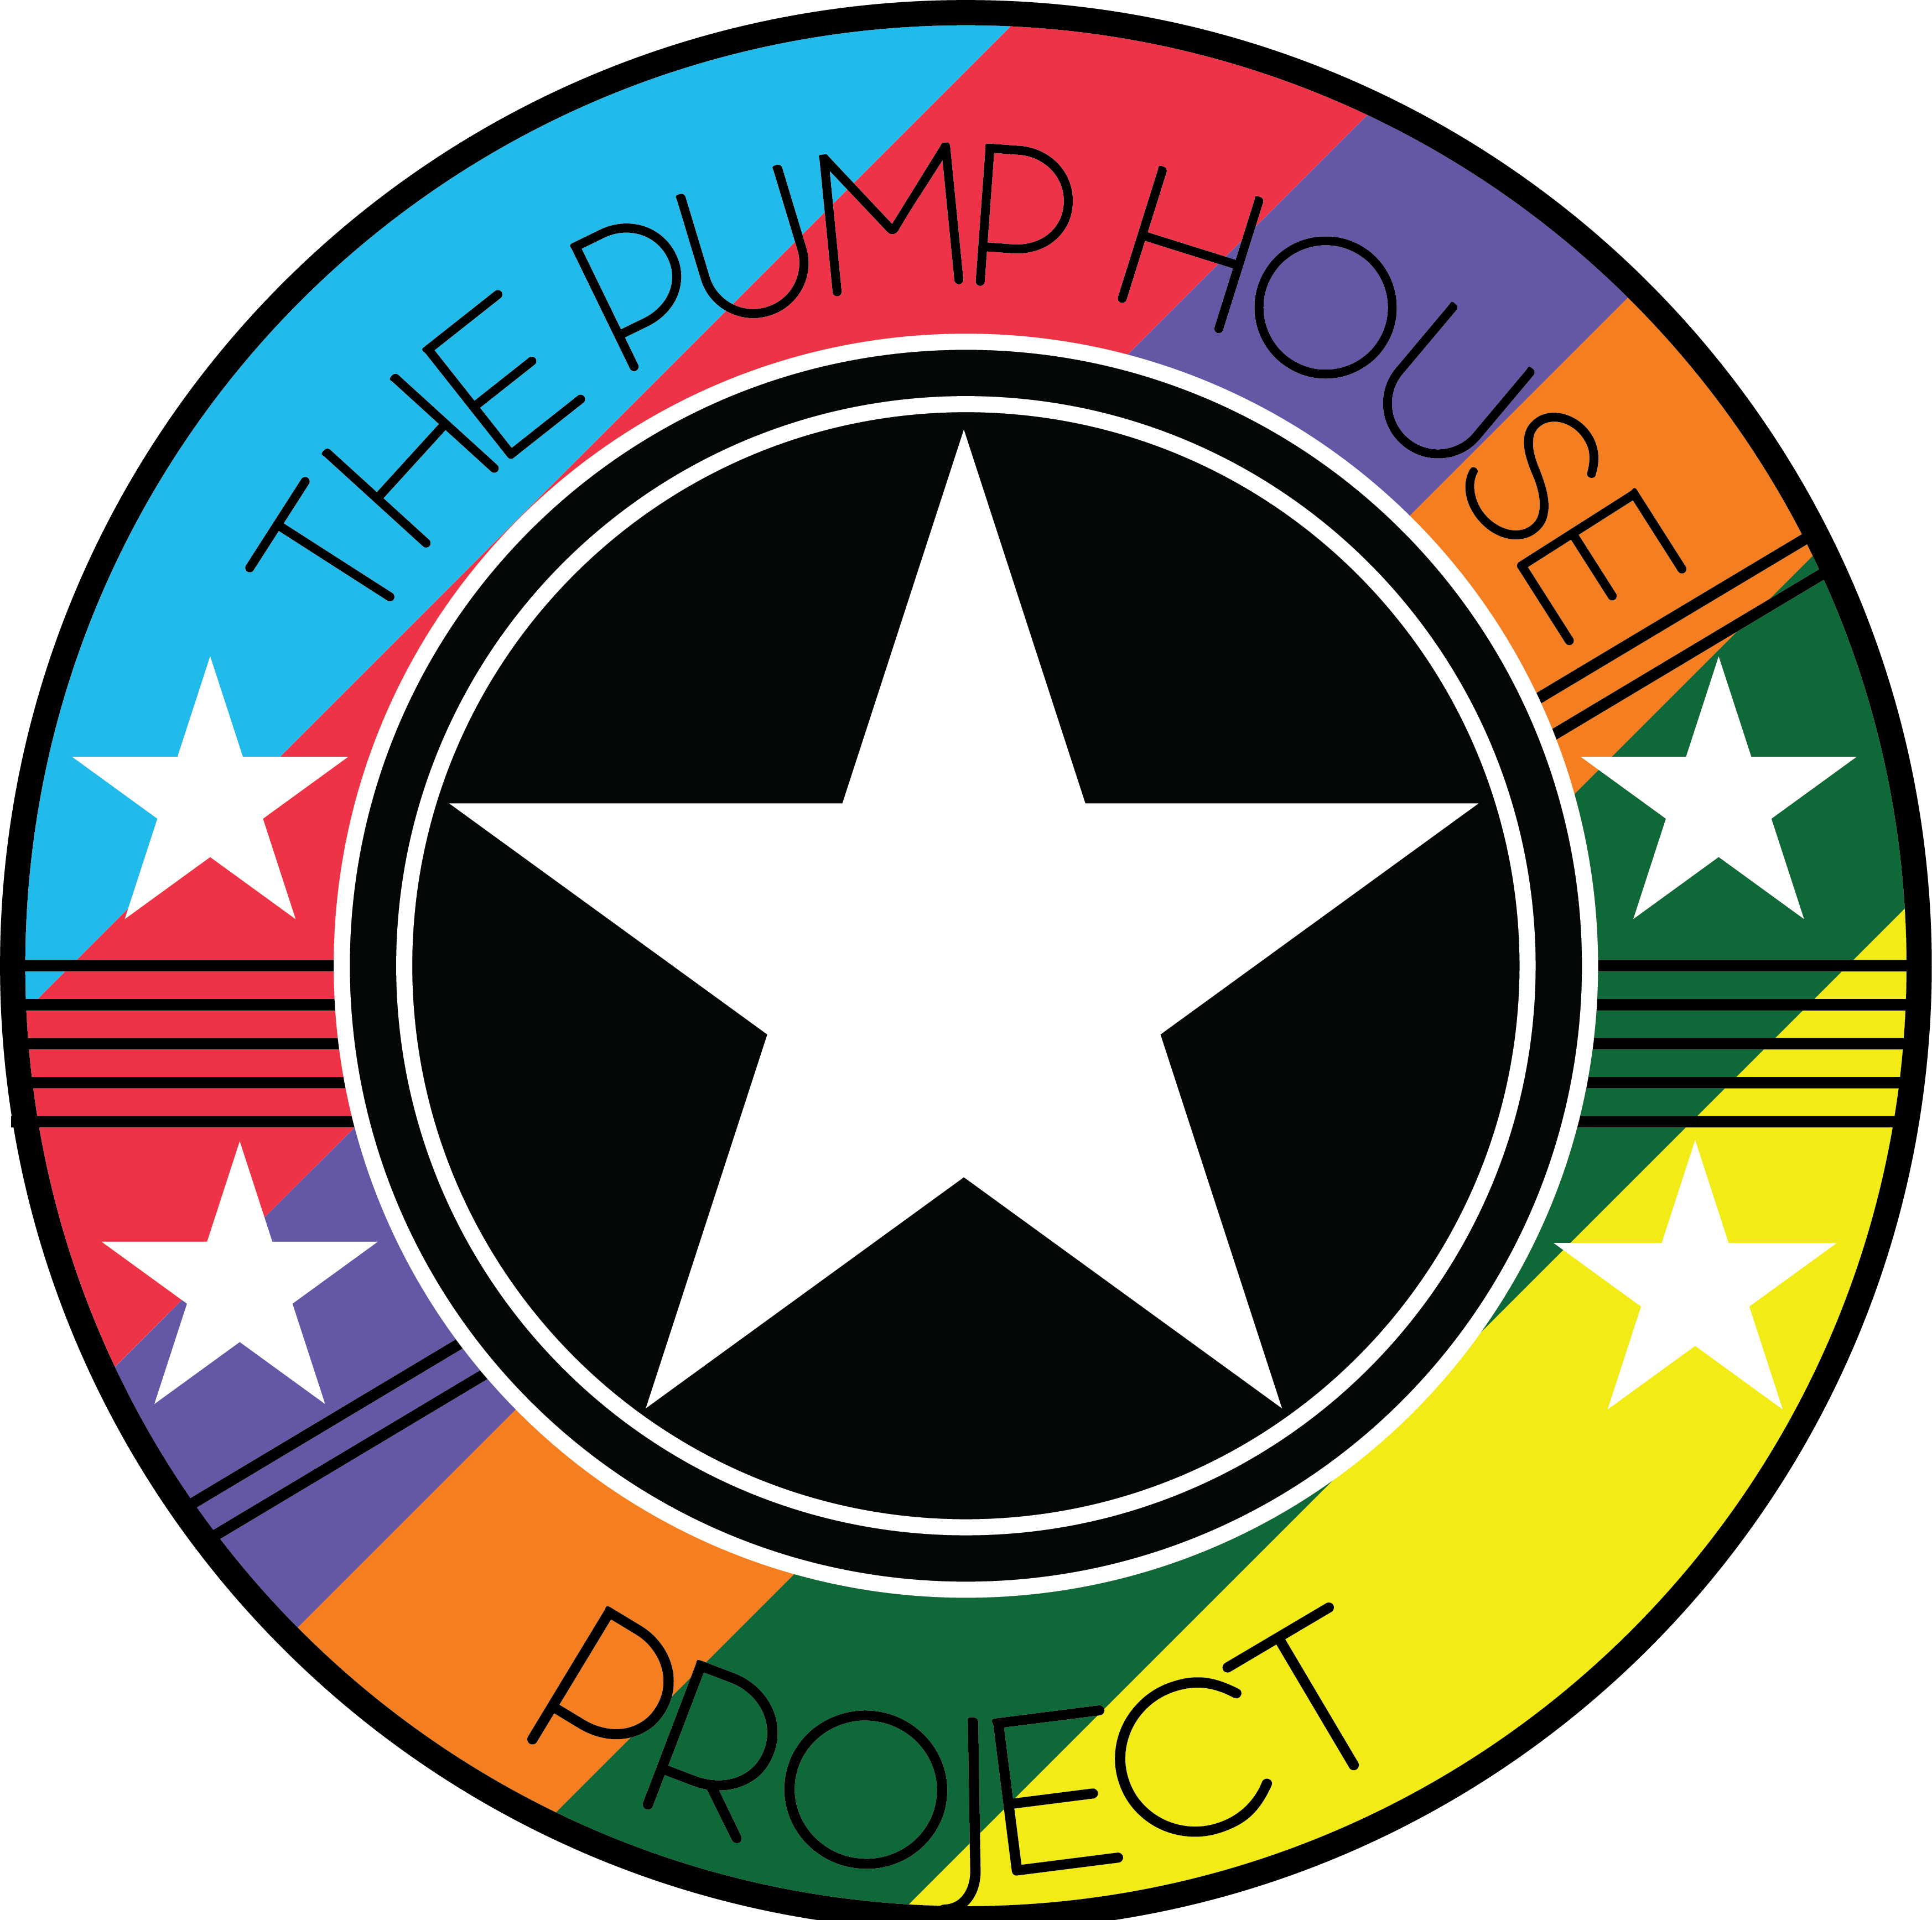

**Risk Assessment Policy**

The Pump House Project recognises that the building, programme and activities should be as safe as is reasonably possible. This includes identifying hazards and quantifying any associated risks.

The Pump House Project will:

Identify the risk assessments to be undertaken and delegate responsibility for carrying out those assessments to the Project Manager.

Make sure staff and volunteers are trained appropriately.

Make sure improvements to premises/activities/events/trips are made when needed.

Once risk assessments have been completed, preventative measures should be evaluated and improved, if necessary.

The Project Manager will make sure that:

* Risk Assessments are carried out at regular intervals for all new activities.
* The completed assessments are stored in the Health and Safety file.
* Staffing ratios of volunteers to attending guests are adequate.
* DBS checks are in place

Policy written by: Sarah Stoves – Project Manager Date: 05/08/2019 Updated on 13/05/2024