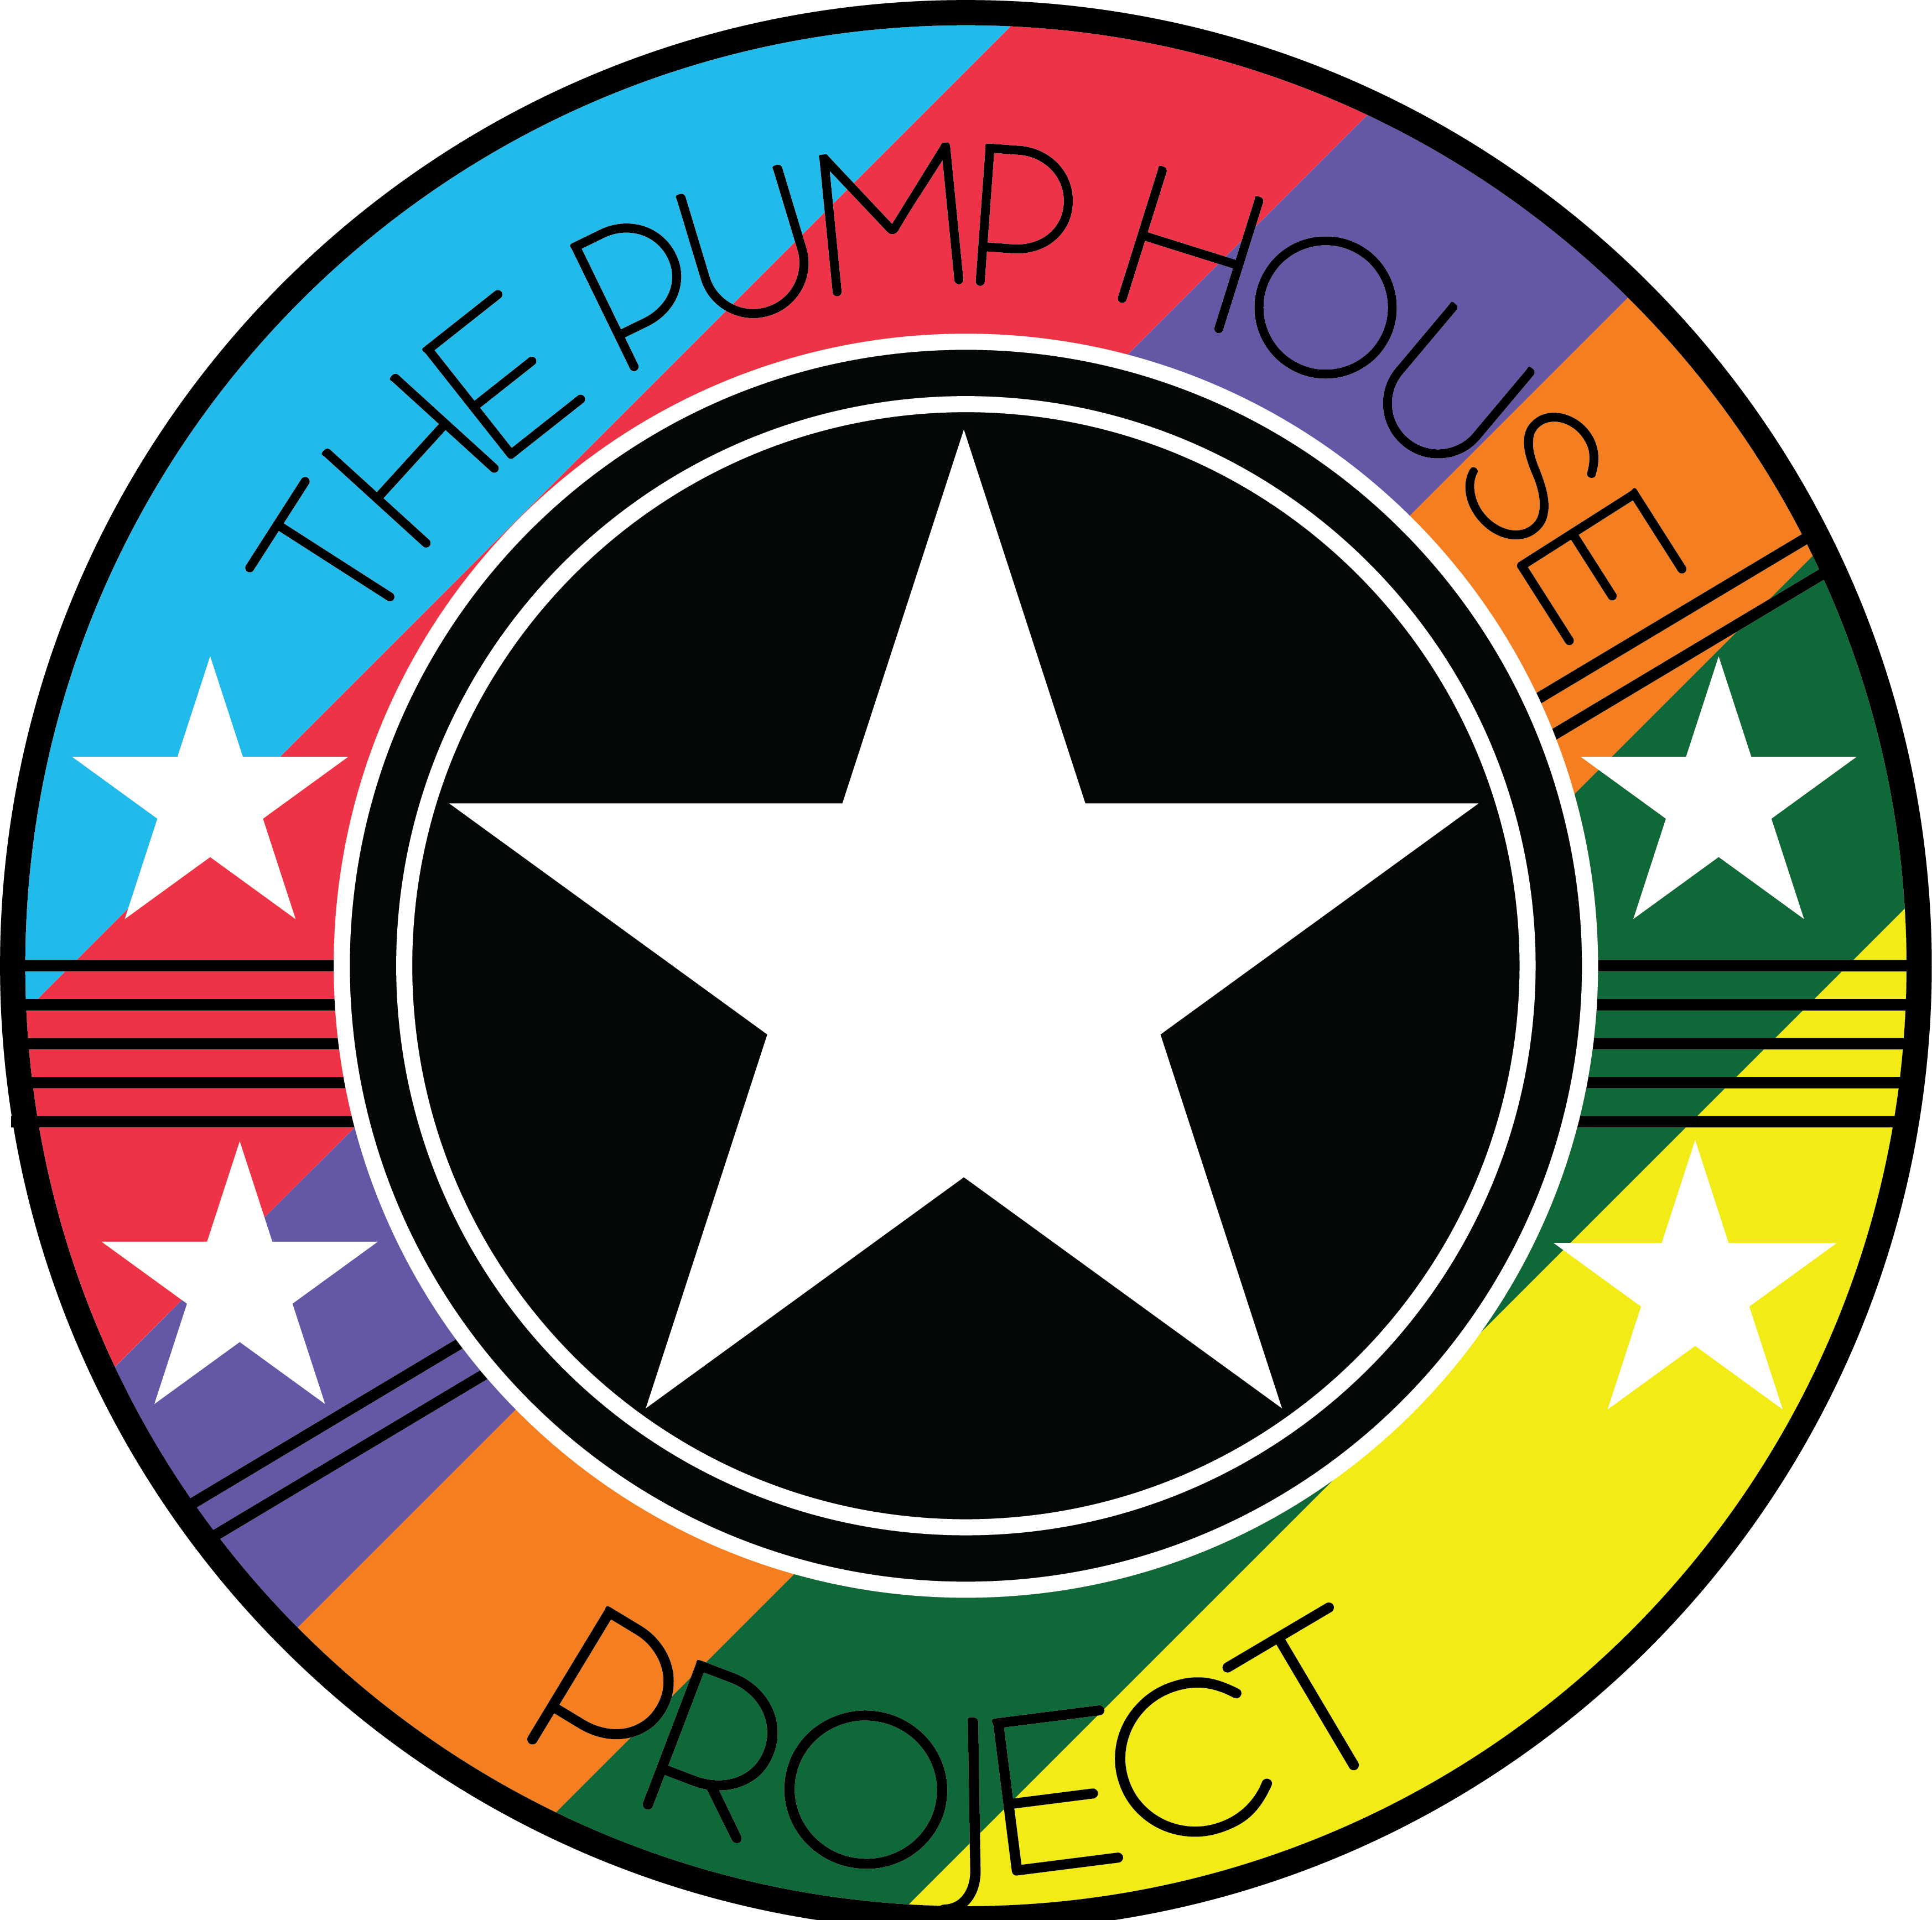

**Smoking Policy**

The Pump House Project operates a designated Smoking Area within the premises.

**Staff and Volunteer Responsibilities**

Staff and volunteers are discouraged to smoke in or around the Pump House Project premises.

Staff and volunteers should discourage young people from smoking and actively support them in their efforts to give up.

Staff and volunteers are responsible for ensuring any visitors to the project adhere to the smoking policy.

Staff and volunteers must not provide any cigarettes, matches or lighters to young people in any youth group or give money, at any time, to young people wanting to purchase cigarettes. They must also not leave any cigarettes or lighters lying around where young people could access them.

Staff and volunteers should communicate the smoking policy to all.

**Young People**

Whilst at The Pump House Project, young people are not allowed to smoke anywhere on the premises.

Any young person caught smoking must be asked to stop or move off the premises.

|  |
| --- |
| Policy written by: Sarah Stoves – Project Manager |
| Date:05/08/2019 |
| Updated: 13/05/2024 |